- Insert some data into a table

query:

INSERT INTO cd.facilities (facid, name, membercost, guestcost, initialoutlay, monthlymaintenance)

VALUES (9, 'Spa', 20, 30, 100000, 800);

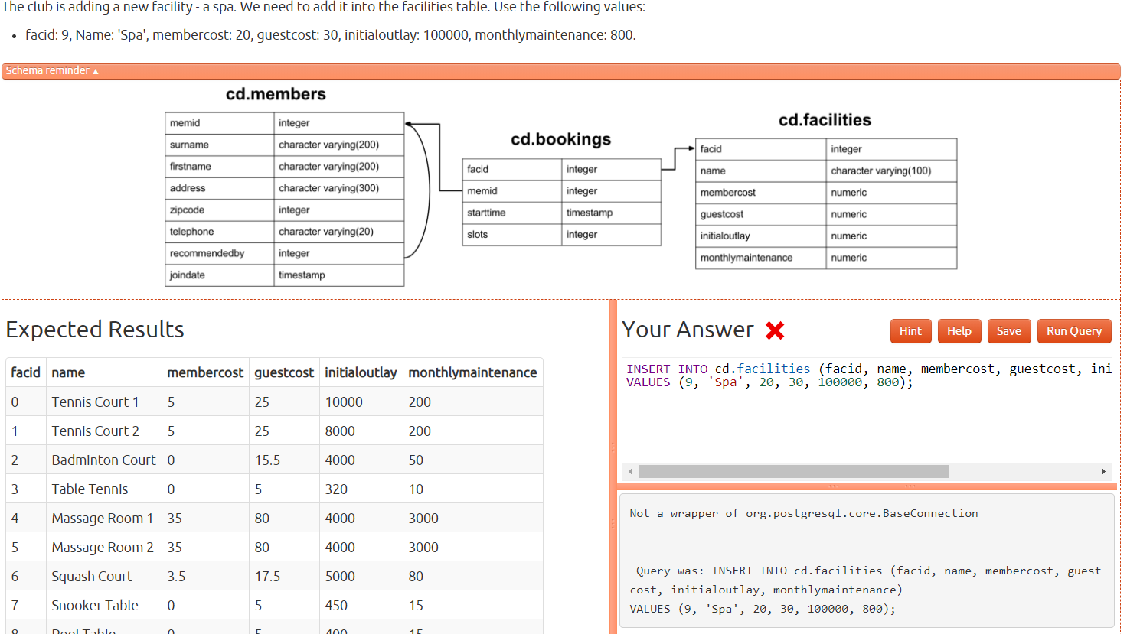

- Insert multiple rows of data into a table

query:

INSERT INTO cd.facilities (facid, name, membercost, guestcost, initialoutlay, monthlymaintenance)

VALUES(9, 'Spa', 20, 30, 100000, 800), (10, 'Squash Court 2', 3.5, 17.5, 5000, 80)

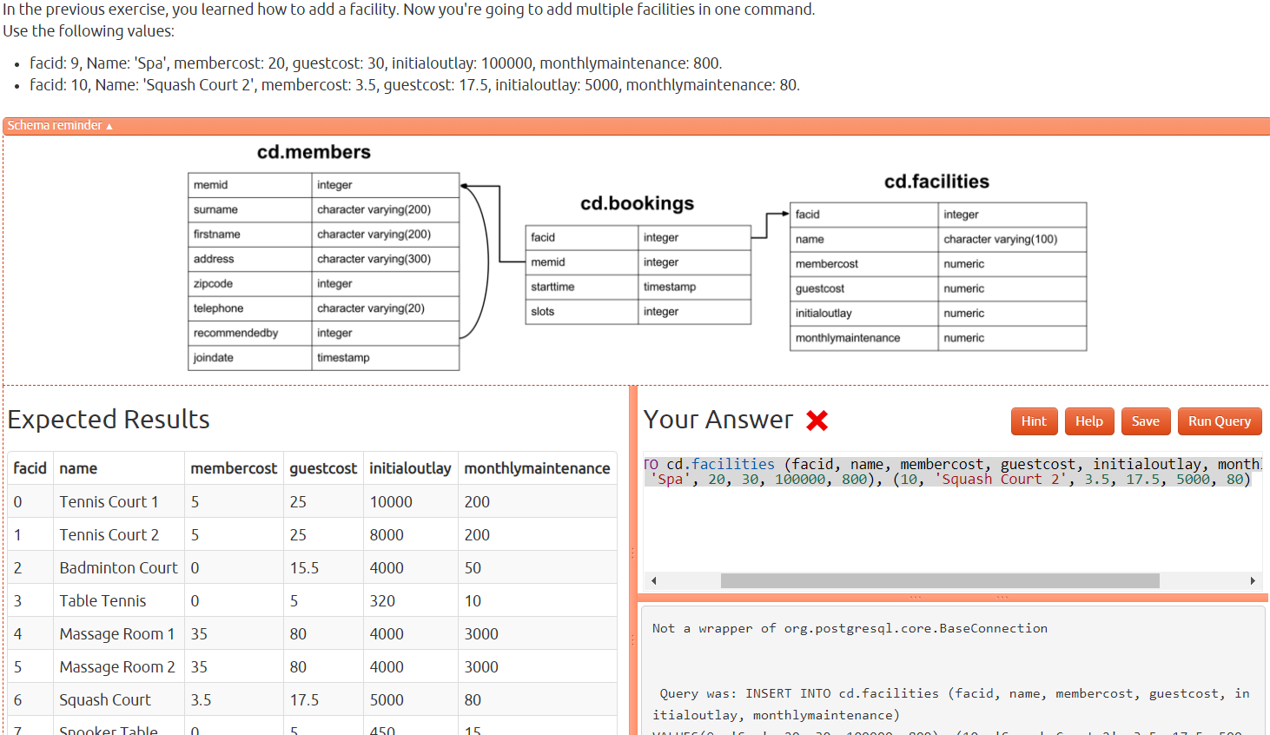

-Insert calculated data into a table

query:

INSERT INTO cd.facilities (name, membercost, guestcost, initialoutlay, monthlymaintenance)

VALUES ('Spa', 20, 30, 100000, 800)

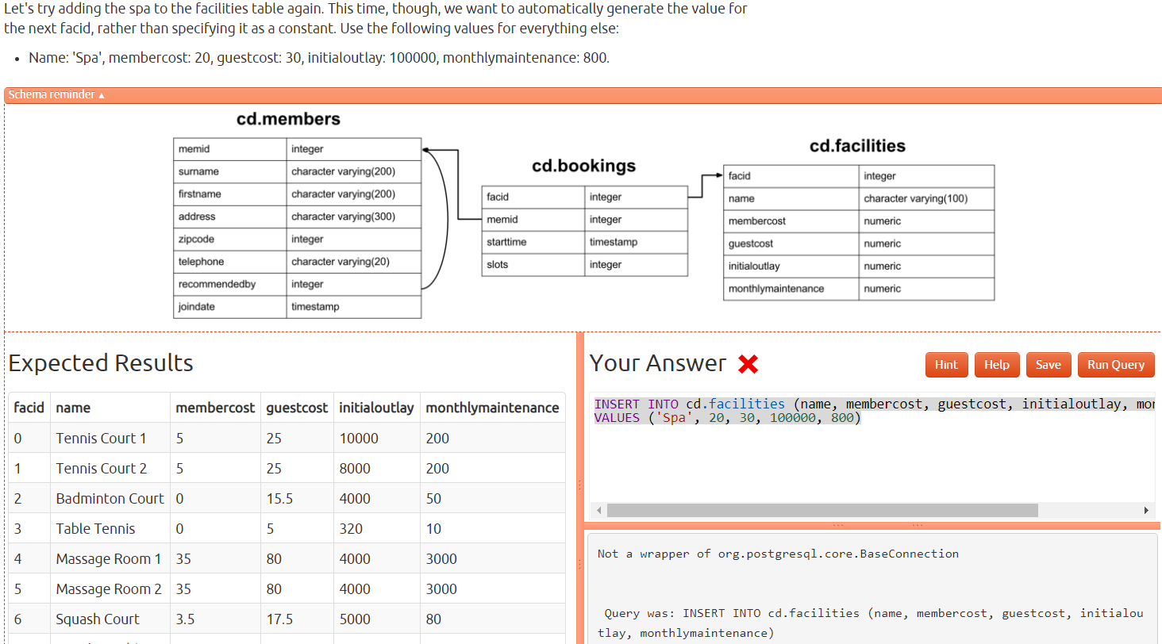

- Update some existing data

query:

UPDATE cd.facilites SET initialoutlay = 1000

WHERE facid = 1

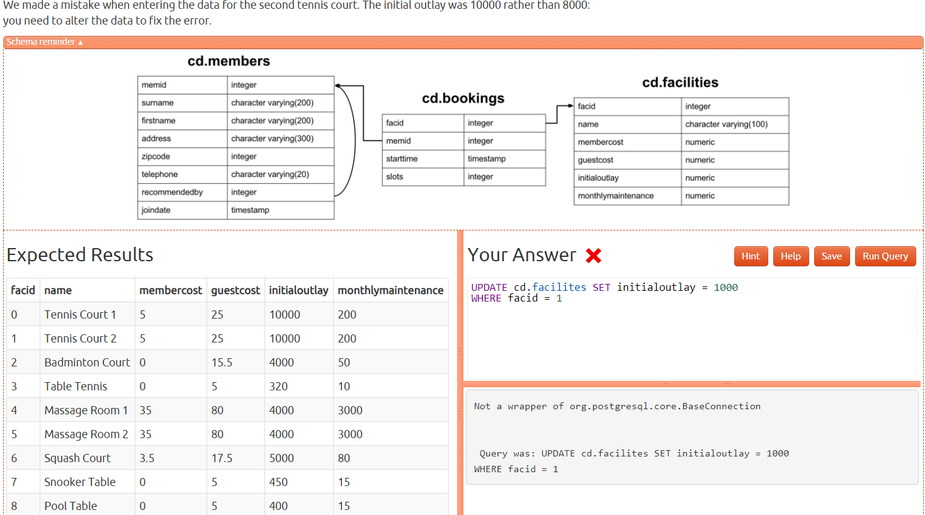- Update multiple rows and columns at the same time

query:

UPDATE cd.facilities SET embercost = 6, guestcost = 30

WHERE name LIKE 'Tennis Court%';

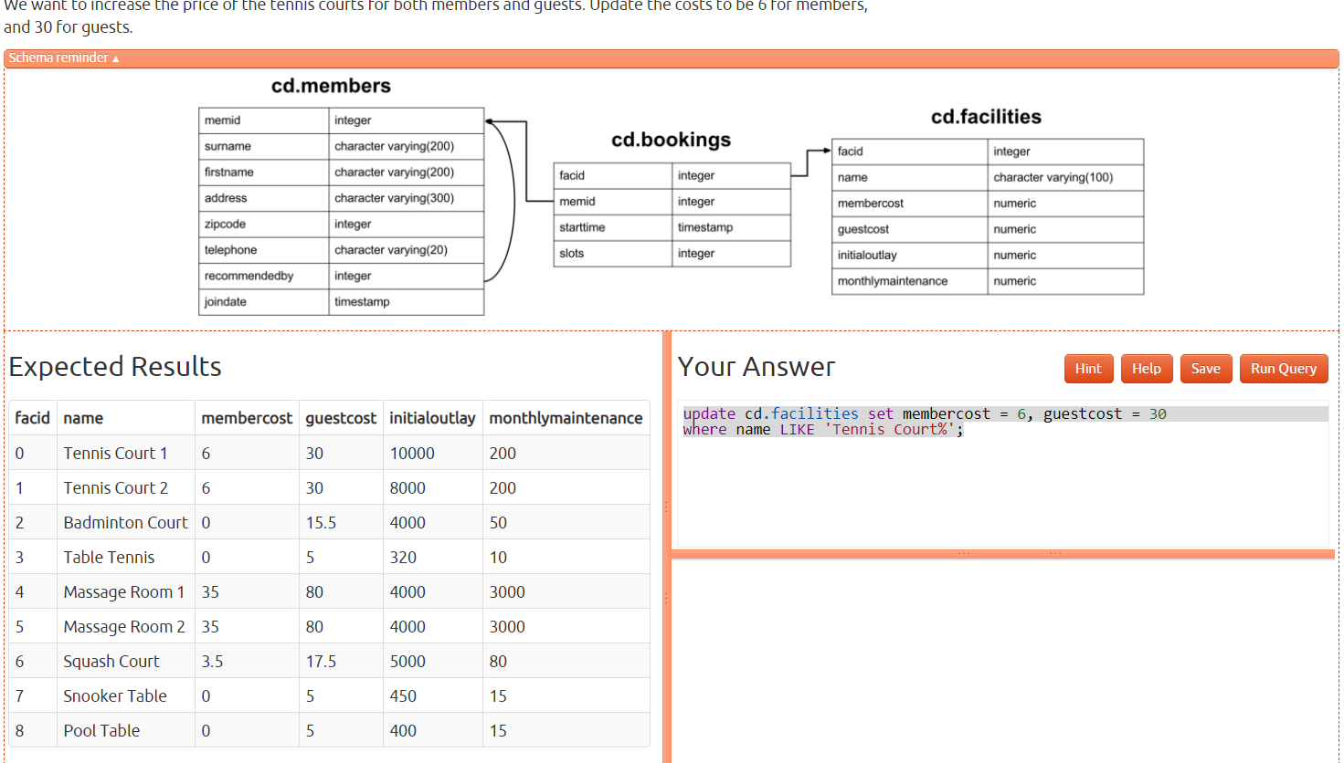

- Update a row based on the contents of another row

Query:

UPDATE cd.facilities

SET

membercost = (SELECT membercost + membercost / 10 FROM cd.facilities WHERE facid = 0),

guestcost= (SELECT guestcost + guestcost / 10 from cd.facilities WHERE facid = 0)

WHERE facs.facid = 1;

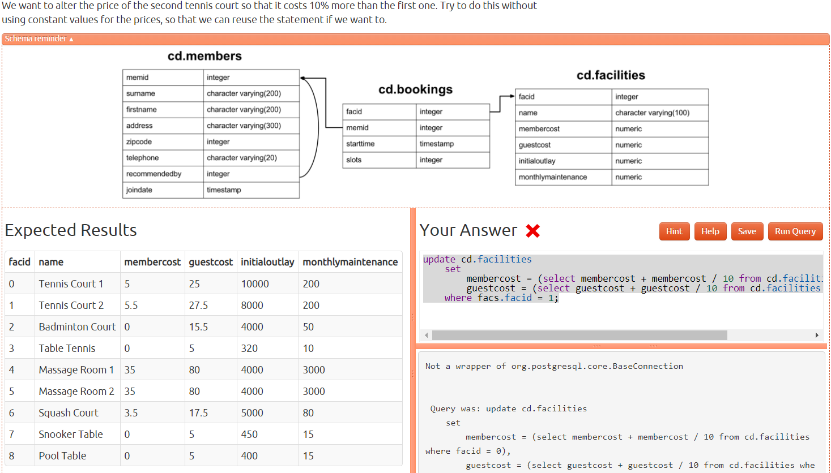

- Delete all bookings

query:

DELETE FROM cd.bookings

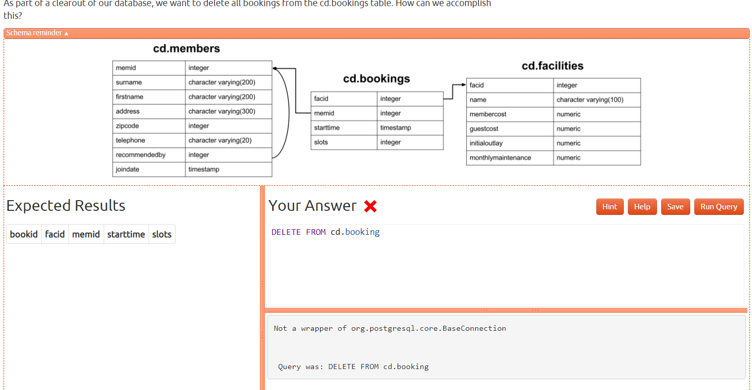

- Delete a member from the cd.members table

query:

DELETE FROM cd.members

WHERE memid = 37;

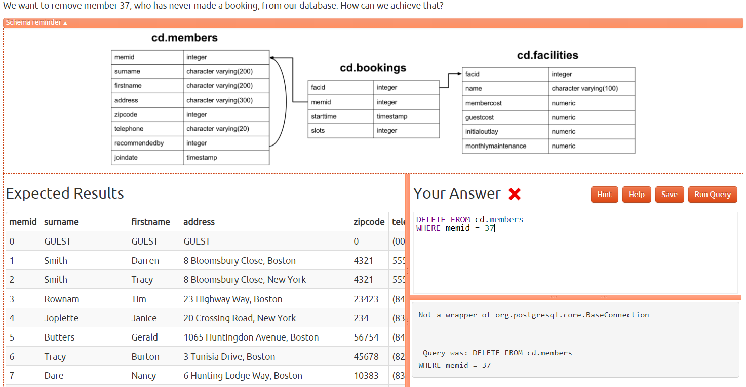

- Delete based on a subquery

query:

DELETE FROM cd.members

WHERE memid NOT IN (SELECT memid FROM cd.bookings);

